Goals:

* Making the claw on the arm grasp onto mobile goals
* Making a clamp that can drag mobile goals
* Adding zip ties to attach the motors to the chassis
* Testing the Inertia Sensor for the programming skills challenge and autonomous period using the Moby Robots (run tests)
* Testing the GPS Sensor for the programming skills challenge using the Moby Robots
* Develop game strategies during the driver-controlled period

Today, Andrew and Kaitlyn attended. We cleaned up the field and the portable. Afterwards, Andrew programmed Blam Bot to move, rotate, move its arms, and grasp using Python. Since Cyrus was not here, we did not continue with the best-chosen solution from the experimental design process planned from January 11.

Brainstorm Solutions:

1. Set the brake type of the motors to hold.
2. Set the brake type of the motors to brake.
3. Set the brake type of the motors or coast.
4. If a motor turns unintentionally due to the weight of the mobile goal, move the motor back to its original position
5. Use the tension of the rubber bands to keep the claw together
6. Continuously move the motor into the grasp position

Select the Best Solution: We chose to use solution 6. When grasping onto the mobile goal, the motor would continue running. However, we found that when the motors are programmed to continue moving but the axle in them would not turn, they would stop until the axle was freed. This would prevent damage to the motor.

Build and Program the Solution: Andrew programmed the motor to continuously grasp.

Test the Solution: Kaitlyn tested the robot and it efficiently grasped onto the mobile goal. A problem we found was that if the mobile goal was removed from the arm with brute force, the claw on the arm would swing since it was programmed to continue moving. This is very dangerous. If a hand or other body part was caught in the path of the arm, it would experience the force of the claw.

Identify Problem: However, a problem we found was that the robot would grasp onto the mobile goal, but when lifting the arms, the mobile goal would fall off.

Brainstorm Solutions:

1. Use the claw kit
2. Use a single fork-type claw on the top of the arms
3. Use two fork-type claws for the arms
4. Use a flat base on the bottom of the arms and a fork-type claw on the top of the arms
5. Use a flat base on the top of the arms and a fork-type claw on the bottom of the arms

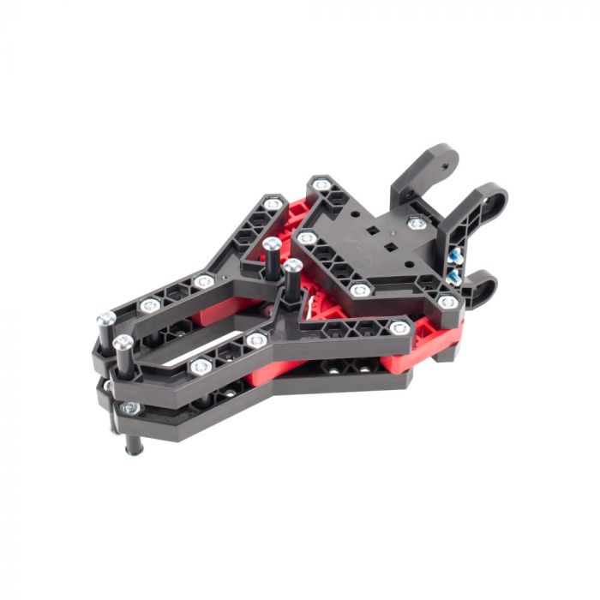

Claw Kit v2

Select the Best Solution: We chose the second solution. This would allow the robot to pickup the mobile goal with only one motor controlling a fork-type claw.

